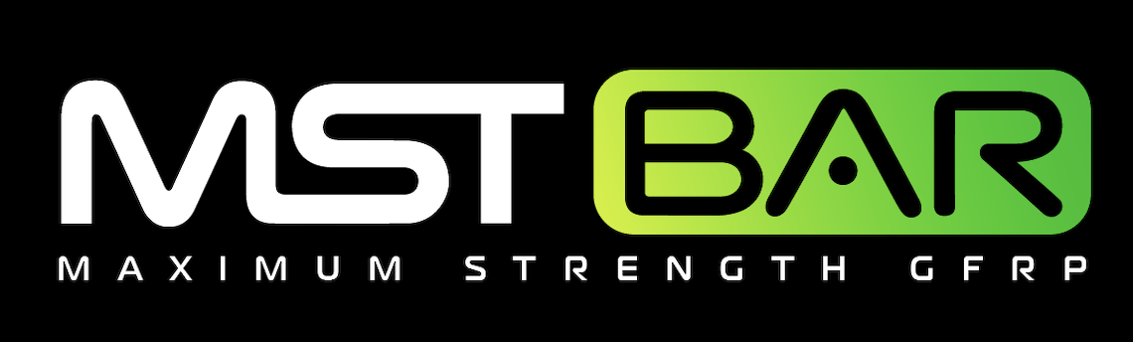June 09, 2021

SUBJECT: Use of 4MAXTM as a 1:1 replacement for #4 Grade 60 Reinforcement in slabs with temperature and shrinkage steel

To Whom It May Concern:

4MAXTM Composite Glass Fiber Reinforced Rebar are high-strength composite reinforcing bar from MST-BAR®. This rebar is made with Vinyl Ester Resin & corrosion-proof ECR Glass Fibers with the following properties:

BAR DIMENSIONS 0.45 in Diameter
CROSS-SECTIONAL AREA 0.16 in2
TENSILE STRENGTH 165 ksi
ELASTIC MODULUS 7550 ksi
SHEAR STRENGTH 27 ksi
PULL-OUT CAPACITY 2900 psi

The 4MAXTM reinforcement may conservatively replace standard slab on grade reinforcement one to one at spacing noted on plans and all other applications where temperature and shrinkage reinforcement governs minimum reinforcement. It is also a replacement for standard #4 and #5 reinforcement in residential foundations including spread and continuous footings, basement walls (under 4 ft), stem walls, and piers. Contact engineering for wall greater than 4 ft.

Always wear gloves when handling 4MAXTM Fiberglass Rebar to protect against fiberglass splinters. Avoid direct contact with skin. When cutting 4MAXTM Glass Fiber Rebar, use a diamond blade for best results. Tie and chair 4MAXTM Glass Fiber Rebar as you would steel rebar. Generally, minimum lap splice length of 15 inches unless otherwise specified by the engineer of record.

The information in this letter is valid until 12/31/2022 when it will be re-evaluated by TUF-N-LITE. Please visit mstbarusa.com for additional pertinent information. If you have questions or need further assistance regarding this matter, please contact TUF-N-LITE engineering at 925.750.0100

Sincerely,
TUF-N-LITE

COMPOSITE REBAR PRODUCTS

